**EXP 2 EMPLOYEE DATABASE**

**Aim:**

Consider the employee database given below

**emp** (emp_id,emp_name, Street_No, city)

**works** (emp_id, company name, salary)

**company** (company name, city)

**manages** (emp_id, manager_id)

**Note: Emp_id should start with ‘E’ in Emp table and emp_id in works table must be the emp_id from emp table .emp_id and manager_id in manages table must be the emp_id from emp table**

create table emp(emp_id varchar(10) primary key check(emp_id like 'E%'),emp_name varchar(25),street_no varchar(10),city varchar(10));

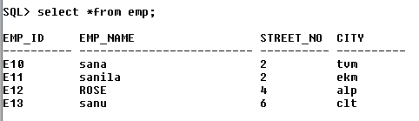

create table company(company_name varchar(20) primary key ,city varchar(20));

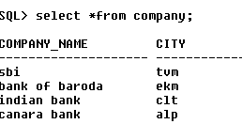

create table works(emp_id varchar(10) references emp(emp_id),company_name varchar(20) references company(company_name),salary number);

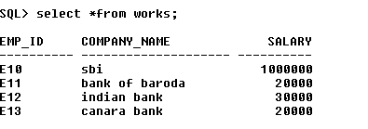

create table manages(emp_id varchar(10) references emp(emp_id),manager_id varchar(10) references emp(emp_id));

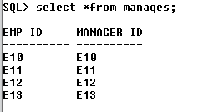

1. Find the names of all employees who work for SBI.

select emp_name from emp,works where company_name='SBI' and emp.emp_id=works.emp_id;



b. Find all employees in the database who live in the same cities as the companies for

which they work.

select emp_name from emp,works,company where emp.emp_id=works.emp_id and works.company_name =company.company_name and emp.city=company.city;



c. Find all employees who earn more than the average salary of all employees of their

company.

select emp_name,emp.emp_id,salary from works,emp Where salary>(select avg(salary) from works a where works.company_name=a.company_name)and emp.emp_id=works.emp_id;



d. Give all managers of SBI a 10 percent raise.

UPDATE works SET salary = salary * 1.1 WHERE emp_id in (select manager_id

from manages) and company_name =’SBT’

UPDATE works SET salary = salary * 1.1 WHERE emp_id in (select manager_id

from manages) and company_name =’SBT’;

UPDATE works SET salary = salary * 1.1 WHERE emp_id in (select manager_id

from manages) and company_name =’SBT’;

update works set salary = salary * 1.1 where emp_id in (select manager_id from manages) and company_name ='SBI';

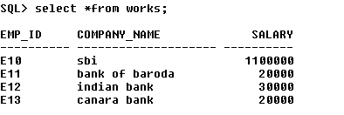

e. Find the company that has the most employees

select company_name from works group by company_name having count(distinct emp_id)>=all(select count (distinct emp_id)from works group by company_name);

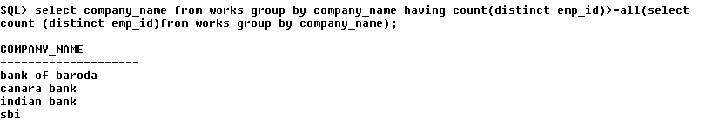

f. Find those companies whose employees earn a higher salary, on average than the

average salary at Indian Bank.

select company_name from works group by company_name having avg(salary)>(select avg(salary) from works where company_name='Indain Bank' group by company_name);



g. Query to find name and salary of all employees who earn more than each employee

of ‘Indian Bank’

select emp_name,salary from works,emp where salary>(select max(salary) from works where company_name='Indain Bank' group by company_name) and emp.emp_id=works.emp_id;

